**C:\Users\JDSDIRECTOR\AppData\Local\Microsoft\Windows\Temporary Internet Files\Content.IE5\JCACF31F\MC900104978[1].wmf**

**C:\Users\JDSDIRECTOR\AppData\Local\Microsoft\Windows\Temporary Internet Files\Content.IE5\B7VT8BPR\MC900104986[1].wmf**

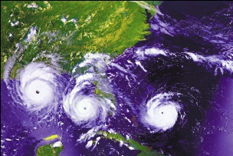

**EMERGENCY CLOSING AND INCLEMENT WEATHER INFORMATION**

It is our intention to be open and provide child care services every weekday of the year, excluding holidays and day school closings. However, situations out of our control such as inclement weather, natural/national disasters, or major building issues may disrupt service from time to time.

As a rule, **we follow the Chesapeake City Public School’s closure schedule for inclement weather**. This vital information will broadcast on local news channels so **please check before venturing out in severe inclement weather.**

In the event that Chesapeake City Public Schools call for a two-hour delay, Jolliff Day School will also follow a two hour delay and doors will open at 9:00AM. Just to clarify, 9:00AM will be the drop off time for ALL students (both full and half day). **Parents of Chittum School-age children will be responsible for taking their child to school on two-hour delay days.**

If Jolliff Day School must close after you have dropped off your child, you or your designated emergency contacts will be notified by Day School management so that you can make appropriate arrangements for picking up your child. In this case, your child must be picked up within one hour of our phone call. Please make sure JDS always has the most up-to-date contact information in your child’s record.

We greatly appreciate your cooperation on these days that may arise and for helping to keep our JDS families and staff SAFE!!!

Sincerely,

Jolliff Day School Administration and Staff